**Rocky Mountain Woodturners**

***A Chapter of the American Association of Woodturners***

***January 2017***

***Contents of Newsletter:***

**REMEMBER**: **Our meetings now are starting at 6:15 instead of 6:30!!**

* Demonstrators for the next few months
* Notes and pictures from the July general meeting, pen turners meeting and Board of Directors meeting.
* RMWT Mentor Directory, Other Items and Events, Items For Sale, RMWT Contact Information, Member Discounts, Clubs and Member Websites
* Learn from the Best

***Notes from AAW***

**AAW EXPLORE!**

[AAW EXPLORE!](http://r20.rs6.net/tn.jsp?f=0015Wii7DrB9BccHMFBQRtCQsLNt2JhKoCMVxqbPHOKYYUKbOheKO5VlvD_E23Su8mcoqkUyHrJMRZTa5Zj3r02bxHFKFLjBTauMTW39Nwx6tRV_AhSDIYJ6_8v2A1RxI1K-IT2DUEjtxVpCtYlTybsaqE-Jb8gGbmh_Gs3cyV81WgOK9-ar8TghWEQc-FzHu11rmiyjEjMK7066VjRuYBA0Q==&c=WB_5bIx-Sjiec-rY-2JqdmGEZwqWE1CVOyEqiG3lCQWFDPy52MgAsA==&ch=Qr2hx5DR1Cmeaz00RlTJSPTLOj85xOUO7vU_W7SZvfTMD8ck8zibEw==) is a new member resource that makes exploring the most extensive online woodturning library in the world, quick, easy, and user-customizable. More than 2,500 items currently make up the expanding EXPLORE! collection, including articles from thirty years of the *American Woodturner* journal and AAW's cumulative collection of complementary publications.

**EXPLORE! is easy to use.**

* Login into the AAW website at [woodturner.org](http://r20.rs6.net/tn.jsp?f=0015Wii7DrB9BccHMFBQRtCQsLNt2JhKoCMVxqbPHOKYYUKbOheKO5Vlq19jmMHsxgaMVGqToYO49khzTA_cj2-WG818fD4uU3HfZ2xpWXixGHBkumKC-VJ8JpS9Bf9928nRYAvM-aYgr1zoAxmsGgAbjqzNkW7r2-ij6jNt9a8xl8=&c=WB_5bIx-Sjiec-rY-2JqdmGEZwqWE1CVOyEqiG3lCQWFDPy52MgAsA==&ch=Qr2hx5DR1Cmeaz00RlTJSPTLOj85xOUO7vU_W7SZvfTMD8ck8zibEw==).
* Under the "**Publications**" tab, select "**AAW EXPLORE!**"
* Select a ***Category*** from the dropdown menu.
* Refine the category by ***Keyword***from the dropdown menu.
* Click the ***Search*** button.
* A list of items (articles and other media) with hyperlinks that meet your search criteria will be displayed.
* Click the "***Globe***" icon associated with any item listed to view it.

**We encourage you to take a look at EXPLORE! and share this exciting new AAW member benefit with others.**

If you haven’t looked into the AAW- You should give it a try. There are literally hundreds of different articles, videos etc. that are available to members. You get a lot of bang for the buck!

***Notes from the General Meeting: 12/8.2016***

***YUMMY!!***

If you missed the December meeting- BUMMER!! We had our annual Christmas Party at Nordy’s on our regular meeting date. A good time was had by all! Good food, good company, and again this year President Doug missed his true calling as an auctioneer.

I believe the final figures from the auction were that we made about $750.00!! That’s a pretty good amount to get from a bunch of rib-stuffed members!

***Pen turners club:***

 Because the pen turning meeting was so close to Christmas, we decided not to have a pen turners meeting this month. We will be back in business in January.

***Beyond the Bark:***

Editors Note: This thank you appeared in last months newsletter, but I would like to run it again. There are a lot of people who helped with the Beyond the Bark show this year, and we had what was possibly our best show yet. I would like to thank again everyone who helped and everyone who participated in the show this winter season.

The 2016 Beyond the Bark exhibit by the Rocky Mountain Woodturners is history now.  It was a wonderful show, filled with many different examples and techniques of woodturning.  Many visitors to the show commented that they had "never seen this kind of wood art before," and how beautiful they thought the pieces were.  Each year we have sold more pieces than the previous year and we are developing a more educated public.  Everyone who helped with the show had a great time.  The gallery is already reserved for the first two weeks of November 2017, which again include the First Friday Art Walk.

Beyond the Bark committee

Editor’s note: While there on “First Friday”, I counted at one point in time, there were 67 people looking at the art exhibit on the walls, and looking a our woodturning. I would guess that there was about a 3-4X turnover of people. That would mean that night alone, somewhere around 250 +/- people saw the Rocky Mountain Woodturners in action. The times I spent there, showing people around, answering questions etc, it seemed like everyone was amazed at the type of work that is being done by our club members. GOOD JOB!! Thanks to all who helped with all aspects of the show, from the planning, to putting up, taking down, manning the exhibit etc.

As a final treat, I thought I’d include some pictures from the Beyond the Bark show and sale.

|  |  |  |
| --- | --- | --- |
| Macintosh HD:Users:clarencesitzman:Documents:Wood Turning:RMWT:2016 Meetings:RMWT October Items:CCC Nov. Show:IMG_1970.JPG | Macintosh HD:Users:clarencesitzman:Documents:Wood Turning:RMWT:2016 Meetings:RMWT October Items:CCC Nov. Show:IMG_1972.JPG | Macintosh HD:Users:clarencesitzman:Documents:Wood Turning:RMWT:2016 Meetings:RMWT October Items:CCC Nov. Show:IMG_1973.JPG |
| Macintosh HD:Users:clarencesitzman:Documents:Wood Turning:RMWT:2016 Meetings:RMWT October Items:CCC Nov. Show:IMG_1974.JPG | Macintosh HD:Users:clarencesitzman:Documents:Wood Turning:RMWT:2016 Meetings:RMWT October Items:CCC Nov. Show:IMG_1975.JPG | Macintosh HD:Users:clarencesitzman:Documents:Wood Turning:RMWT:2016 Meetings:RMWT October Items:CCC Nov. Show:IMG_1976.JPG |
| Macintosh HD:Users:clarencesitzman:Documents:Wood Turning:RMWT:2016 Meetings:RMWT October Items:CCC Nov. Show:IMG_1978.JPG | Macintosh HD:Users:clarencesitzman:Documents:Wood Turning:RMWT:2016 Meetings:RMWT October Items:CCC Nov. Show:IMG_1989.JPG | Macintosh HD:Users:clarencesitzman:Documents:Wood Turning:RMWT:2016 Meetings:RMWT October Items:CCC Nov. Show:IMG_1994.JPG |
| Macintosh HD:Users:clarencesitzman:Documents:Wood Turning:RMWT:2016 Meetings:RMWT October Items:CCC Nov. Show:IMG_2000.JPG | Macintosh HD:Users:clarencesitzman:Documents:Wood Turning:RMWT:2016 Meetings:RMWT October Items:CCC Nov. Show:IMG_1991.JPG | Macintosh HD:Users:clarencesitzman:Documents:Wood Turning:RMWT:2016 Meetings:RMWT October Items:CCC Nov. Show:IMG_2000.JPG |

***A VERY IMPORTANT MESSAGE from President Doug:***

A big reminder to ALL members, that we will be electing a completely new slate of officers at the January meeting.  If you are getting interested in doing something, let your friends know so that this election will go smoothly.  Let's NOT wait until at the meeting to try and figure out who our next officer's candidates are going to be.  This is crucial to the future operations of the club.  Due to club bylaws, our current officers must relinquish their authority at that meeting due to term limits.  I will not continue on as President.

***Tonight’s Speaker: Our very own Doug Schneiter:***

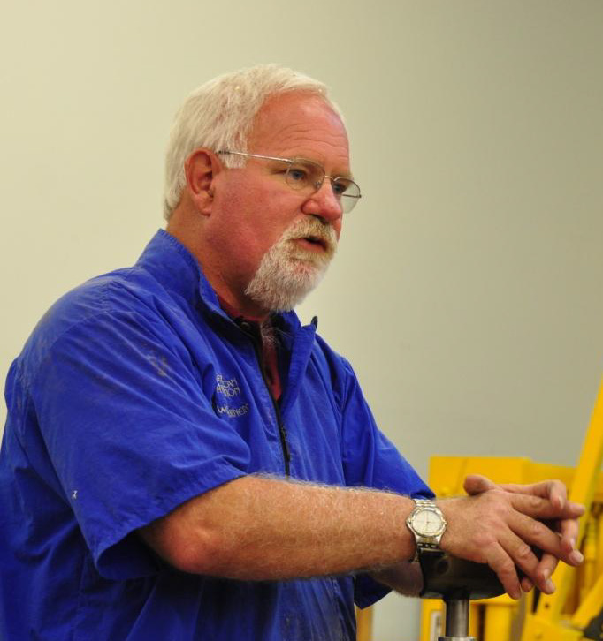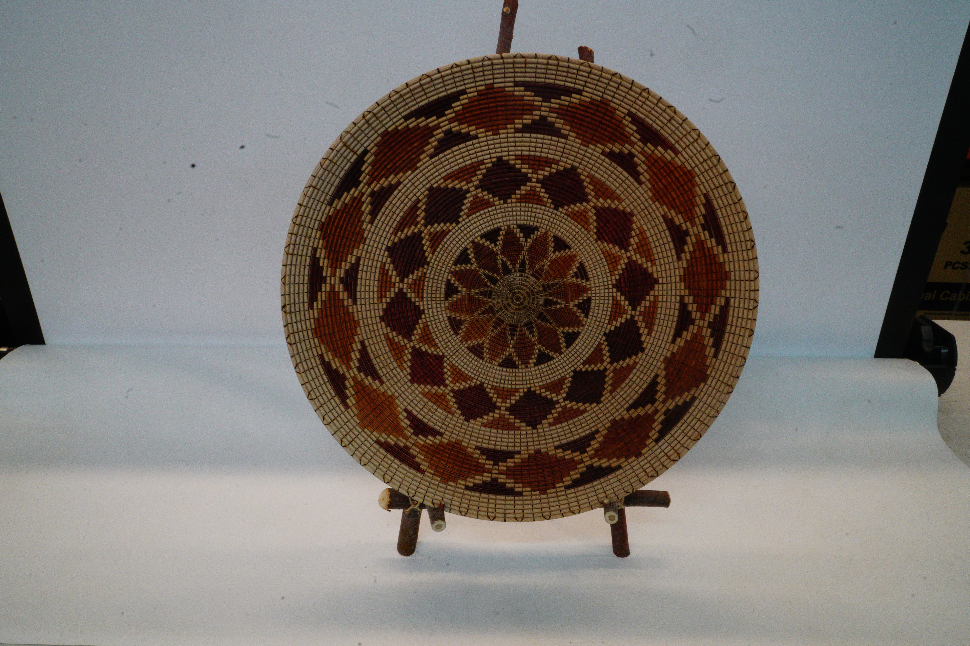

Hi, I'm Doug Schneiter, a transplanted Iowa farm boy now living in the Wild West.  After spending most of my high school days in the woodshop, I then moved to the woodshop at Univ. of Northern Iowa, where I received my B.A. Degree which led to 3 years of teaching Industrial Arts in Iowa.  I then moved to Colorado to teach at C.S.U. while earning my Master's Degree.  After a short teaching stint in New Mexico, I took a 12 1/2 year sabbatical from teaching.  In the Fall of '93, I was offered a teaching job at Loveland High School which lasted for 21 years.  My moving out here coincided with the AAW Symposium being held at CSU, and with the formation of the Rocky Mountain Woodturners Club.  Getting involved with the club and meeting some of the outstanding members is what got me started down this path of turning obsession.  It has been an amazing trip, and I have enjoyed every bit of it.  When I came to Loveland, I thought that I was a pretty decent turner, even though at that time I was primarily a spindle turner, not too good at turning bowls, and had not yet turned a hollow form.  But after seeing all of the evolution and growth that had take want n place in the 12 years that I was away from turning, I knew that I was starting all over again from square one, and I want to thank all of the early members of RMWT who helped, mentored, assisted, taught, critiqued, and encouraged me to become the turner that I am today.  I certainly could not have made this trip by myself.

The demo that I will be doing, will be creating a basket weave dish.  I will be starting with a rough blank, shaping the form using my personal favorite tools and techniques.  Once the dish is shaped, I will demonstrate my method of using beading tools, and then show how to get the radial lines onto the turning, both on the lathe, and burning them in later using the pyrography pen.  The next step will be prepping the piece for the coloring process.  After deciding what design to put on the piece, I'll show you my method, and preferred pens for coloring.  Assuming that I have enough time, I plan on being able to show all of you all of the steps involved in making a basket illusion bowl, and still have time to answer questions you may have regarding this process.  You can call it whatever you want; basket illusion, allusion, or even delusion.  Sometimes, any of these descriptors are appropriate.

Doug Schneiter

***Upcoming meetings:***

**February 9, 2017 RMWT Monthly Meeting**

**Bob Franklin - review of EOG Grant for Trent Bosch Class**

**March 9, 2017 RMWT Monthly Meeting**

[**Tom Boley**](http://www.redoakhollow.com/index.php)

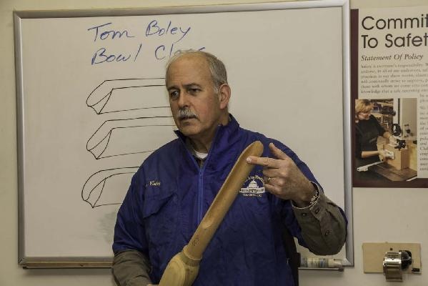

**April 6, 2017 RMWT Monthly Meeting**

[**Vinny Luciani**](http://www.vinnyluciani.com/)

I was born into woodworking.....my father owned a custom furniture shop on Long Island N.Y.

I learned from him all the tools and tricks he learned as an apprentice in the "old Country", Italy.

Through all these years of furniture building, antique restoration and duplication, it is the wood itself that I enjoy.....it`s nature, history, and character. I owned an antique restoration shop for 18 years. This is where the beginnings of my passion for wood LATHE work began, duplicating antique finials and other elements of fine furniture. I am now a full time independent woodturner, working with the medium I still love.....figured woods of all kinds, chainsawn and mounted on the lathe, drawing on a on a lifetime of experience and observation.

In my work, I strive to combine the tactile and visual nature of wood with my perceptions of form and line, actual and implied. The pieces often require extensive carving and shaping along with the lathe work. Inspiraton arises most often from my awareness and observations of organic forms all around us. ...for example, my latest "Ocean" series which is inspired by the theme of endangered ocean reefs and my experiences with the ocean.

I am proud to be a part of the wood turning community here in Colorado Springs as a member of the local Pikes Peak Woodturners club and as a member of the American Association of Woodturners. I am an avid student of the many masters in this field and constantly study and aspire to become a better artist. In 2013 I was the featured artist in the October issue of Woodturning Design Magazine.

***RMWT Mentor Directory:***

Seven RMWT club members have registered to be mentors for those who would like to discuss and practice woodturning techniques that they have not yet mastered. Please contact a mentor directly from the directory on the website at: <http://rmwt.org/mentor.htm>

***Wood Bank Guidelines:***

<http://www.rmwt.org/articles/2013-rnwt-wood-bank-guidelines.pdf>

***Items For Sale:***

Editor’s Note: These articles of items for sale have run their course. They will not be featured in the next issue unless we are contacted and you would like them to run in additional issues.

**GOTTA CLOSE IT DOWN SALE:**

Powermatic 3520B Lathe with 18" bed extension, full mobility system, vacuum pump, adapter and hardware

    Two(2) Vicmarc VM120 Chucks with 7 jaw sets

    Two(2) Screw center chucks

    Six(6) aftermarket tool rests (Robust, Oneway, Vicmarc)

    Woodcut Bowl Saver

Laguna LT-14 SUV 14" Bandsaw with three blades and mobile lift

Powermatic PM1300TX Dust Collector with 4 inch flex hoses, attachments and mobility package

Jet Disc/Belt Sander JSG-96 with misc. sanding pads, belts and mobile base

Powermatic 17" Drill Press with custom table and mobile base

Clamps and custom rolling clamp stand

    18 Bessey K-series clamps (24, 40, and 50 inches) and clamp connectors

     8 Bessey TGJ2 clamps (6, 12, and 18 inches)

    Jet Clamp Kit (2x24, 2x40)

    Multiple additional clamps

Clean and well maintained.  Priced to sell...entire lot $6,250.  Specific items from above list could be for sale, but at higher individual prices than lot price reflects. Please call :

Jim French [(970) 461-3545](callto:+1%28970%29%20461-3545)

**Rodney Taylor**LATHE/JET 1220VS - 3/4 hp, 115v, swing -12”, bed - 20 ‘, variable speed 200-4300

Includes: 2 sets - tool rests - Robust 4” & 9” / JET 6” & 10”, 1 face plate - 3”,1 - live center, 1 - spur center (Sorby), 1 - 6” tool caddy, 1 - knockout rod, 1 - work lamp, 1 – manual indexing - 24 positions.

Asking $600.00. Contact: Rodney Taylor 303-859-4315. e-mail: [rodney.taylor@colorado.edu](mailto:rodney.taylor@colorado.edu)

**Wood and equipment for sale:** I still have too much stuff to fit into the new shop. This is not trash stuff, but primo pieces from my long term hoarding of the best wood. Exotics (including some nice pieces of Cocobolo), Aussie Burl offcuts, Mesquite burl, large platter blanks of Pau Amarello, Mahogany, and Cherry, and other choice pieces.

**Shopsmith 10ER ($200)** This is a vintage Shopsmith model 10ER, serial number 37519. It is an older model of Shopsmith, not the one that has all the attachments. If you know these machines, you know what it is. It is in good working order. A couple of the knobs are broken, and have been replaced. I have saved the originals to fix. Includes Table saw table, Disk Sander disk, 4 arbors, Drill Chuck, Table Saw Fence, a Miter Gauge for the table saw, that looks home made and not original. It has the lathe tailstock part, but not the table saw extention table that goes on it, or the toolrest for the lathe. The motor is 1/3hp, single phase 115VAC. The variable speed drive is working well. This is a nice vintage machine in good condition. Made back when the best machines in the world were made in America! A classy machine, very well built.

Pictures on the Craigslist post here: <http://fortcollins.craigslist.org/tls/5654168334.html>

**Legacy Ornamental Mill Model 1000 ($2000)** The Legacy Ornamental Mill/Lathe is for fluting, reeding, twists, and other router milling on wood. This model is an older one, Model 1000. It is not CNC or power feed. Total length of machine 86" x 26". Workspace size about 69" x 8". I got this machine to do some replacement balusters for the Stanley Hotel several years ago. Now I have moved into a smaller shop and need the space. Does a variety of pitches, including some non-standard ones. Everything works very well. Router (with height adjustment), extra gears, owners manual included.

Pictures on the Craigslist post here: <http://denver.craigslist.org/tls/5654957334.html>

Please contact me to come take a look. Best is email <[cindy@cindydrozda.com](mailto:cindy@cindydrozda.com)>, or text [303-449-7170](tel:303-449-7170). Voice calls are ok, too. Please leave a message and I will call you back.

**Cindy Drozda: PO Box 19065 Boulder, CO 80308 [303-449-7170](tel:303-449-7170)**

**From: Dave Hawley**

**FOR SALE – Jamieson Deep Hollowing System – Captured Package**,**$200** ([www.packardwoodworks.com](http://www.packardwoodworks.com) price incl S&H $418)

Reliable and easy to use system – takes stress out of hollowing. Includes (a) Jamieson stabilizing D-handle with safety clip, (b) ¾” boring bar (has 90° and 45° ends) (c) straight holder w swivel tip and HSS cutter (3/16” square stock purchasable online at Enco or MSC), (d) shop-made back rest that has a total of four O-1 steel bars top and bottom, with 36” of travel for ease of use (Jamieson back rest has only 20” travel), (e) Jamieson laser attachment, and (f) new laser. System is currently used with a Powermatic 3520B lathe, but the back rest may easily be modified to work with any full-size lathe by simply changing the height. May use with any ¾” or less hollowing tools, carbide cutters, and security camera system.

A DVD on the use of this Jamieson hollowing system is in the Front Range Woodturner’s Chapter library and is also purchasable on Lyle Jamieson’s website.

Contact Dave Hawley at 303-443-2332.

|  |
| --- |
| Macintosh HD:Users:clarencesitzman:Desktop:JamiesonSysPic_7Aug16.JPG |

This is the second running of these requests:

***From a member from long ago: Dwayne Fisher***

|  |  |
| --- | --- |
| Macintosh HD:Users:clarencesitzman:Desktop:Dwane Fisher items:IMG_2005.JPG | Macintosh HD:Users:clarencesitzman:Desktop:Dwane Fisher items:IMG_2006.JPG |
| Black and Decker s ¼ HP Dewast 10” commercial duty radial saw model 7770. Manual available. | Guardian Power 16 speed ¾ hp motor. Mfg 1988. 5/8# capacity. Model FDM 165P on Stand. |
| Macintosh HD:Users:clarencesitzman:Desktop:Dwane Fisher items:IMG_2007.JPG | Macintosh HD:Users:clarencesitzman:Desktop:Dwane Fisher items:IMG_2008.JPG |
| Delta Lathe mounted on table. 500-3,000rpm. ¾ hp motor, 12” variable speed. Model 46-700. | Grizzley Dust collector 1HP, 1988 |

If you are interested in any of the above items, please call Lyndel Saxbury at 482-8042.

***Next:***

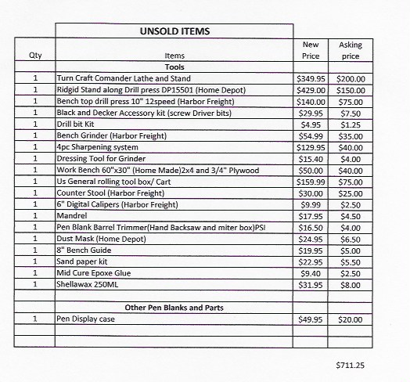

For any of the above items, contact: "Martin Christensen" <[mecturning@gmail.com](mailto:mecturning@gmail.com)>

***Last Sale item***

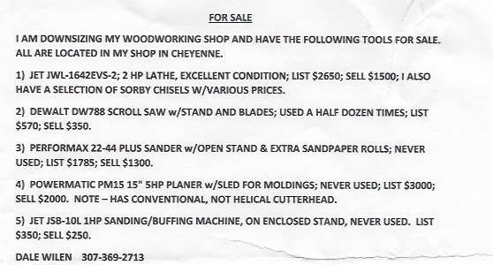

***Editor’s note:*** Sale ads will run for three months unless notified to stop sooner or to continue longer. Please call or e-mail your ad to the Newsletter Editor at the address below.

\_\_\_\_\_\_\_\_\_\_\_\_\_\_\_\_\_\_\_\_\_\_\_\_\_\_\_\_\_\_\_\_\_\_\_\_\_\_\_\_\_\_\_\_\_\_\_\_\_\_\_\_\_\_\_\_\_\_\_\_\_\_\_\_\_\_\_\_\_\_

***RMWT Contact Information:***

**President:** Doug Schneiter

970-817-6046

[dougschneiter@gmail.com](mailto:dougschneiter@gmail.com)

**Vice President:** Jim Felton

307-634-9103

[jpfelton@gmail.com](mailto:jpfelton@gmail.com)

**Treasurer:** Ron Thompson

970-224-4125

[Ront2737@hotmail.com](mailto:Ront2737@hotmail.com)

**Secretary:** Clarence Sitzman

970-980-8403

[seesitzman@aol.com](mailto:seesitzman@aol.com)

**Program Director:**

Camille Wall

303-543-2267

[camille\_wall@hotmail.com](mailto:camille_wall@hotmail.com)

**Newsletter Editor:** Clarence Sitzman

970-980-8403

[seesitzman@aol.com](mailto:seesitzman@aol.com)

**Wood Bank:** John Giem

Chairman and Wood Lot Manager

970 223-0844 home

970 227-6618 mobile

[jgiem@comcast.net](mailto:jgiem@comcast.net)

**Wood Lot Collection:** Jerry Sherman

970-631-2984 mobile

970-484-2619 home

**RMWT Webmaster:** Hoyle Curtis

970-613-1415

[Hoyle.Curtis@gmail.com](mailto:Hoyle.Curtis@gmail.com)

**RMWT Symposium:**

**General Coordinator:** Allen Jensen

970 663-1868 work

970 776-6452 mobile

**Vendor Coordinator:** Cindy Drozda

P.O. Box 19065

Boulder, CO 80308

303-449-7170

[cindy@cindydrozda.com](mailto:cindy@cindydrozda.com)

<http://cindydrozda.blogspot.com>

<http://www.youtube.com/user/condydrozda>

Facebook business page: <http://tinyurl.com/44prp3n>

Facebook Profile: <http://tinyurl.com/3vy5ld5>

Twitter: http:twitter.com/cindydrozda

**Program Coordinator:** Trent Bosch

[trent@trentbosch.com](mailto:trent@trentbosch.com)

**Symposium Registration Coordinators:** Jim and Pam Felton

307-634-9103 home

[jpfelton@gmail.com](mailto:jpfelton@gmail.com)

\_\_\_\_\_\_\_\_\_\_\_\_\_\_\_\_\_\_\_\_\_\_\_\_\_\_\_\_\_\_\_

***10% RMWT Member Discounts (with some exceptions):***

**Wood Emporium**

618 N Garfield Ave

Loveland, CO

970-667-5621 Phone

970-667-5621 Fax

**Sears-Trostel Lumber & Millwork**

1500 Riverside Ave

Ft. Collins, CO 80524

970-482-1928

970-482-9895 Fax

**Woodcraft – Loveland**

3718 Draft Horse Drive

Loveland, CO 80538

970-292-5940 Phone

970-292-5939 Fax

[loveland@woodcraft.com](mailto:loveland@woodcraft.com)

**Rockler’s in Denver** – You have to show your membership card.

\_\_\_\_\_\_\_\_\_\_\_\_\_\_\_\_\_\_\_\_\_\_\_\_\_\_\_\_\_\_\_

***Clubs and Member’s Websites:***

**Rocky Mountain Wood Turners**

[www.rmwt.org](http://www.rmwt.org)

**AAW – American Assoc. of Woodturners**

[www.woodturner.org](http://www.woodturner.org)

**Trent Bosch**

[www.trentbosch.com](http://www.trentbosch.com)

**Cindy Drozda**

[www.cindydrozda.com](http://www.cindydrozda.com)

<http://cindydrozda.blogspot.com>

<http://www.youtube.com/user/condydrozda>

Facebook business page: <http://tinyurl.com/44prp3n>

Facebook Profile: <http://tinyurl.com/3vy5ld5>

Twitter: http:twitter.com/cindydrozda

**John Lynch**

[www.johnlynchwoodworking.com](http://www.johnlynchwoodworking.com)

**Curt Theobald**

[www.curttheobald.com](http://www.curttheobald.com)

**Don Maul**

[**www.bighornwoodart.com**](http://www.bighornwoodart.com)

**Dale Bonertz**

[**www.roughoutbowls.com**](http://www.roughoutbowls.com)

**Harry R. Farmer**

**harryrfarmer@q.com**

***Learn From the Best…***

The Rocky Mountain Woodturners Club, RMWT, is well known around the nation because we have some of the best national and internationally known demonstrators and best teachers of Basic, Intermediate, Advanced and Specialty turning right here in our own back yard:

**Trent Bosch Woodturning Workshops:**

Workshops are held in Trent’s studio in Fort Collins, Colorado. There is a maximum of four people in each class, which allows for lots of individualized instruction. The cost is $500 for the 3-day intensive workshop and $650 for the 4-day. Meals are also provided at no extra charge. His studio is also equipped with the highest quality equipment available for your use. For detailed information on workshops visit [www.trentbosch.com](http://www.trentbosch.com) or contact Trent via email or phone.

**Trent Bosch**

Trent Bosch Studios Inc.

[trent@trentbosch.com](mailto:trent@trentbosch.com)

970-568-3299

**Rocky Mountain School of Woodturning** operated by **Lee Carter** in LaPorte, Colorado. He offers classes in Basics, Intermediate and Advanced. Lee also offers private tutoring. Seven different brands of lathes are available.

Call Lee Carter at 970-221-4382 to sign up or have him answer any questions.  [leecarterrmsw@yahoo.com](mailto:%20leecarterrmsw@yahoo.com)

\_\_\_\_\_\_\_\_\_\_\_\_\_\_\_\_\_\_\_\_\_\_\_\_\_\_\_\_\_\_

**Curt Theobald** offers three-day workshops in Segmented Woodturning in his studio in Pine Bluffs, Wyoming.

Call Curt Theobald at 307-245-3310

E-mail: [cwtheobald@wyoming.com](mailto:cwtheobald@wyoming.com)

Website: [www.curttheobald.com](http://www.curttheobald.com)

**John Giem,   Woodturner**

Custom woodworking and Individual or small group woodworking instruction tailored to the needs of the student. Offering both woodworking on the lathe and combined with regular power tools. Classes are held in John's studio in Fort Collins, CO, which is equipped with a complete set of woodworking tools. Contact John to discuss your interests and needs.

[jgiem@comcast.net](mailto:jgiem@comcast.net)

(970)223-0844, home

(970)227-6618, cell

### Woodcraft has classes for beginners in

### woodworking, shop safety, intro to the machines, bowl turning, pen and pencil turning, hollow forms, Christmas tree ornaments, tool sharpening, etc.  Please check out the classes being offered at web page: [www.woodcraft.com/stores/storeaspx?id=56](http://www.woodcraft.com/stores/storeaspx?id=56)

**Doug Schneiter** is scheduled to teach several woodturning classes at Woodcraft - Loveland in 2015.  See the class schedules at Woodcraft.  Doug also teaches specialized one on one classes on turning at his studio in Loveland.  Contact at dougschneiter@gmail.com

From: Harrry Farmer: I have glue! I can be reached by calling my cell phone (970)218-0297 or home phone (970) 484-5448.  My address is 2112 Springfield Ct., Ft. Collins.  Email address is [harryrfarmer@q.com](mailto:harryrfarmer@q.com).  I am available most times but would be better to call ahead to be sure I am home.